Balasaheb Desai College, Patan
Activity Report
Name of the Department – Chemistry
( 2023-24) Under DBT STAR College Activity
Name of the Activity: Vivek Vahini Vidnyan Vahini Date : 19/1/2024
Students Participation: 22 Venue: Krishi Vigyan Kendra kalawade Karad
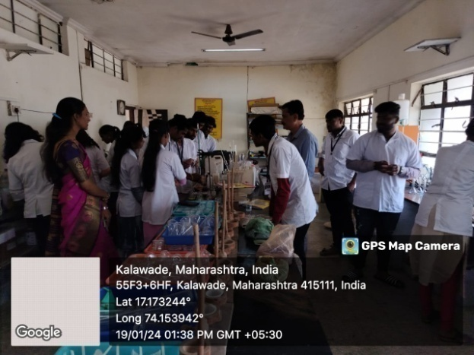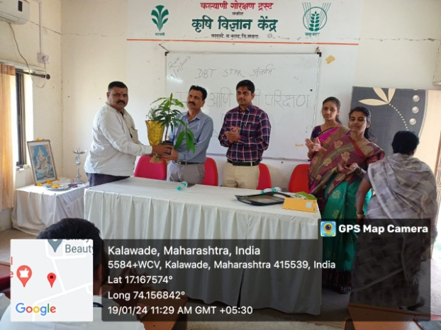

Dr.Bharat Khandekar ,Dr.V.A.Kalantre , Mr. M.S. Aldar, Miss. A. S. Loharand krushi vidnyan kendre kalawade
Objective of activity :
- To demonstrate the new improved technology to the farmers as well as to the extension agency directly in the farmers field with their active participation.
- To identify the area specific problems of the farmers and prioritization of the identified problems as per their importance.
- To collect feedback from farmers and extension agencies and to provide linkages with scientists for the modification or refinement of technology.
- To impart training to the practicing farmers, rural youth and extension functionaries for capacity building.
- To provide new and important information on agriculture and allied sectors to the extension agencies or NGO’s for wider circulation to improve their economic condition.
- To prepare different extension models and verify these models in the farmers field with their participation to create confidence among them
Outcome of activity : It can be concluded that Krishi Vigyan Kendras provide requisite knowledge through trainings and other activities to improve the skill and attitude of the people towards a particular subject, provide proper guidance to solve any problem faced by the farming community in agriculture and allied fields.
Introductory Speech : Dr.Dilip Ghongade
Name of the Guest : Dr.Bharat Khandekar
Chairperson of the activity : Dr.V.A.Kalantre
Vote of Thanks : Mr.M.S.Aldar

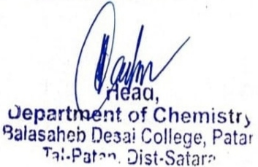
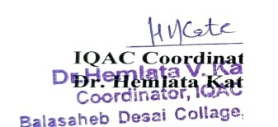

Convener IQAC Coordinator Principal

Dr.V.A.Kalantre Dr.S.D.Pawar

