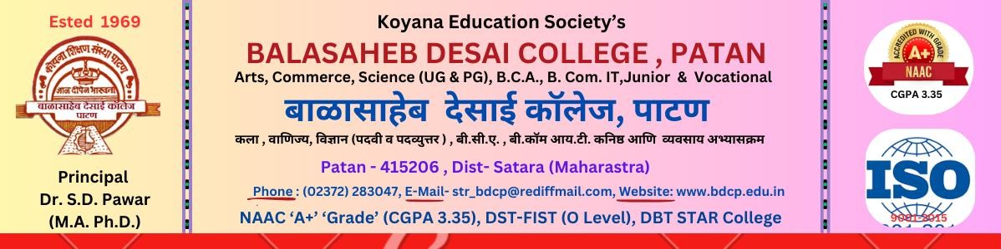

Department of Microbiology

Cross Cutting Issues
2023-24

Sr. No | Cross Cutting Issue | Course Name | Integration of Cross Cutting Issues
Sr. No | Cross Cutting Issue | Course Name | Paper/Sem. No. | Unit
1 | Environment and Sustainability | B. Sc. Part I | Paper No. II Basic Techniques in Microbiology | Unit 2: Control of Microorganisms
1 | Environment and Sustainability | B. Sc. Part II | Paper No. VI applied Microbiology | Unit I: Air, Water, Milk  microbiology
1 | Environment and Sustainability | B. Sc. Part III | Sem V | Paper No. XI food and industrial Microbiology Paper no. XII Agricultural Microbiology
1 | Environment and Sustainability | B. Sc. Part III | Sem VI | Paper No. XV environmental Microbiology  Paper no. XVI Medical Microbiology

