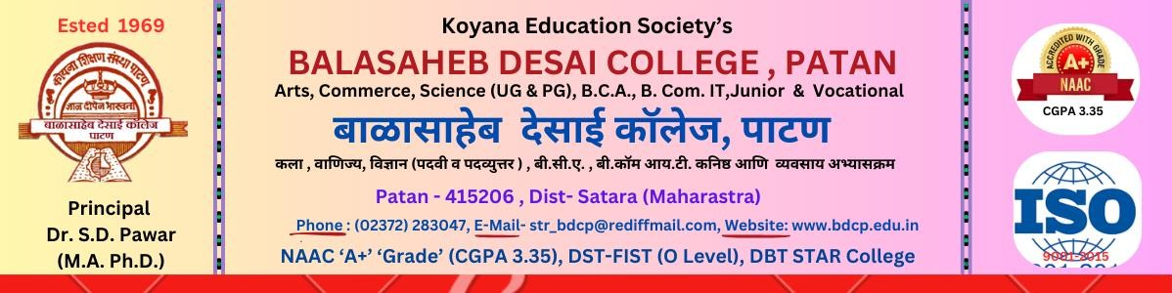

Department of Chemistry

Cross Cutting Issues
2023-24

Sr. No | Cross Cutting Issue | Course Name | Integration of Cross Cutting Issues
Sr. No | Cross Cutting Issue | Course Name | Paper No | Unit
1 | Environment and Sustainability | B. Sc. Part I | Paper No. IV Analytical Chemistry | Unit 4: Water Analysis  Unit 5: Analysis of fertilizers
1 | Environment and Sustainability | B. Sc. Part II | Paper No. VI Industrial Chemistry | Unit III: Corrosion and Electroplating Unit IV: Paper Industry Unit V: Soaps and Detergents
1 | Environment and Sustainability | B. Sc. Part III | Paper No. XII Analytical Chemistry | Unit 5: Chromatographic techniques and Quality control
1 | Environment and Sustainability | M. Sc Part I | Paper-VII Physical Chemistry II | UNIT-II: Photochemistry
1 | Environment and Sustainability | M. Sc Part II | Paper No. –XII Analytical Chemistry | UNIT-I: Sampling in analysis UNIT-II: Electrochemical and spectral methods Environmental analysis UNIT-III: Air and Water Pollutant Analysis
