
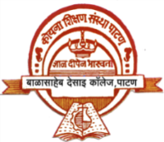
NAAC :-" A+ " Grade

KOYANA EDUCATION SOCIETIY’S

BALASAHEB DESAI COLLEGE, PATAN certified

One Page Report
Activity Report of Study Tour under DBT Star College Scheme
Department of Botany and Zoology

Place Visited : Patan, Baneshwar, Katraj Pune, Jejuri, Naranpur,Pratibalaji,Patan
Participated students -38 Class-B.Sc.I
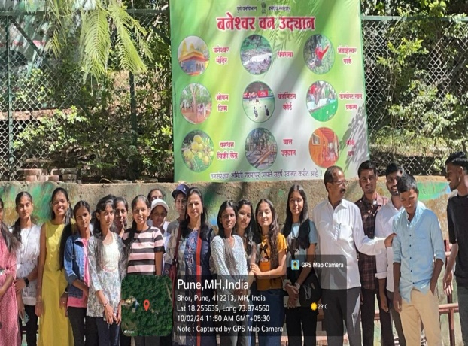
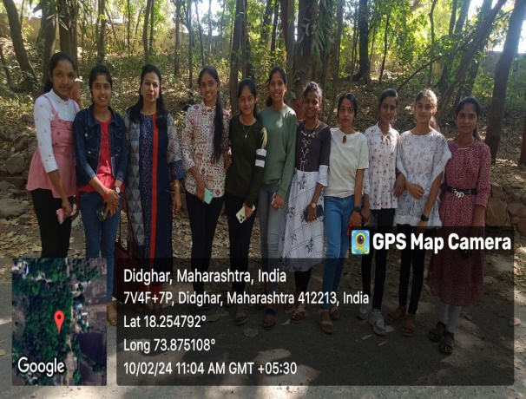
Date: 10/2/2024

Objective-
To Make student aware about Biodiversity.ecology and flora and Fauna at diffreent places.
Outcomes of activity –
Students becomes awere of Nature conservation. Subject knowledge increased. Plant species collected by students to prepaere herbarium Sheets.Ecological parameters producers, condsumers, decomposers observed by students ingrass land ecosystem.
Teachers participated- Dr.L.J .Bhingardeve, Dr.M.R.Shinde, Mr.P.R.Gaikwad.
Report:Study tour mainly focused to show student varied flora and Fauna.Seasonals, weeds, orchides, herbs, shurbs, small animals. This place is rich in Biodiversity. A variety of Frogs, Insects, Crabs, Birds were observed by students. Plants species collected by students for study.

Convener coordinator Principal

Balasaheb Desai College Patan
Department of Botany
Feed Back Analysis

Name of the Activity- Study Tour toPatan, Baneshwar, Katraj Pune, Jejuri, Naranpur,Pratibalaji,Patan
Participated students -38 Date: 10/02/2 024
Excellent | Very Good | Good | Fair | Total
38 | 38 | - | - | 38

Head
Department of Botany

